**MVHS Academic Honesty Policy**

**Rationale/statement of purpose for the policy**

At MVHS we strive for students to be: engaged learners, critical thinkers, effective communicators and responsible 21st century citizens. Our school motto is “Do it the R.I.T.E way, the Nighthawk way, with Respect, Integrity, Teamwork and Excellence". These school-wide learning objectives are consistent with the IB Learner Profile, particularly the characteristics of being principled and caring. It is essential that our students are developing elements of honesty to be prepared for the both the collegiate and work force expected behaviors. With many pressures these students face, it is important that we model and teach honesty in a social and educational setting. The purpose of this document is to instruct and provide skills to prevent malpractice.

**Details and advice on student responsibilities**

According to section 3.4 in *Academic honesty* it is stated, “the candidate is ultimately responsible for ensuring that all work submitted for assessment is authentic, with the work or ideas of others fully and correctly acknowledged. Candidates are expected to comply with all internal school deadlines; this is for their own benefit and may allow time for revising work that is of doubtful authorship before the submission of the final version” (p. 8). It is our expectation that students will follow the modeled instructions for ensuring authentic work, such as proper citation procedure and demonstrating the difference between collaboration and collusion. According to 1.4 in *Academic honesty*, “collaboration may be loosely defined as working together on a common aim with shared information, which is an open and cooperative behavior that does not result in ‘allowing one’s work to be copied or submitted for assessment by another" (p. 2).

**Details and advice on teacher responsibilities**

It is the responsibility of Diploma Programme teachers to support candidates in the preparation of their work for assessment and to ensure that all candidates’ work complies with the requirements of the relevant subject guide. Therefore, teachers (or supervisors in the case of extended essays) are well placed to judge whether a candidate’s work is authentic. Ongoing support and guidance will help with the early detection of plagiarism and will dissuade candidates from deliberately copying another person’s work without acknowledgment because they know their work is regularly subject to scrutiny. [*Handbook of Procedures*, 2015] Teachers will include an academic honesty statement in their syllabi and reference this document electronically for students and parents.

For all assessments for IB, “it is the responsibility of the teacher to confirm that, to the best of his or her knowledge, all candidates’ work accepted or submitted for assessment is the authentic work of each candidate” (*Academic honesty*, p. 7).

**Details and advice on school responsibilities**

The school is responsible for creating, promoting, and monitoring academic honesty. The school will examine the policies and procedures established at the school to identify inconsistencies for future change of policies. The school must allow for due process and uphold the rights of the student. The school’s responsibility is to review the evidence and provide opportunity for the student to respond and allow for fairness. The school needs to examine its reporting procedure to allow more thorough investigation prior to alleging an intentional breach of academic honesty. The goal of the school is to examine intent in order to redirect and instruct on proper strategies. It is the school’s responsibility to clarify that IB will not consider intent if misconduct is identified. It is the school’s responsibility to report any evidence of misconduct. All teachers and examiners are provided with professional development to understand the academic honesty policy and how to use the resources available to them at MVHS. It is the school’s responsibility to provide a safe learning environment and proper room conditions for assessments per IB code for conducting exams. The school must inform all students prior to the DP exams the rules and regulations for conducting IB exams. To promote parent awareness, an orientation to the MYP or the DP is held and policies and regulations are discussed. All documents are made available to parents and the community on the school website.

**Details and advice on parent responsibilities**

It is important for parents to provide honest feedback and expectations for their children. The school would like to see parents support the integrity of their child. It is their responsibility to encourage their children to talk to their instructors and seek out support when needed. It is the responsibility of the parents to read and discuss the MVHS IB Academic Honesty Policy, IB Honor Code, and the MVHS Handbook outlining procedures and supports to prevent misconduct prior to signing to any documents. Before entering the Middle Years Program or the Diploma Program, both students and parents must sign the IB Honor code.

**Measures taken to provide education and support**

Teachers are responsible for instructing the students on how to demonstrate academic honesty and explain examples of misconduct. They must provide examples, modeling and testing for works cited, in-text citation, quality of sources used, how the sources are used, and formative assessment. Teachers need to provide explicit and specific instructions for the assignments to understand what is or is not allowed. Teachers need to utilize Turnitin as an instructional tool rather than simply an inspection tool that allows students to revise work that may be done incorrectly. Teachers need to teach students how to use the available resources, such as EBSCO and Questia, two online databases, for searching for sources. Students need to be taught how to do scholarly searches using the world-wide web and discern the legitimacy and objectivity of sources. Teachers need to provide concrete evidence of any suspected breach of academic honesty to ensure fairness, rather than a personal “gut feeling”.

For all assessments for IB, “it is the responsibility of the teacher to confirm that, to the best of his or her knowledge, all candidates’ work accepted or submitted for assessment is the authentic work of each candidate” (*Academic honesty*, p. 7). Students must be given time for revision of mistakes. Mistakes are seen as an opportunity for learning and growth rather than a penalty on their grade.

See diagram below from *Handbook of Procedures,* 2015.

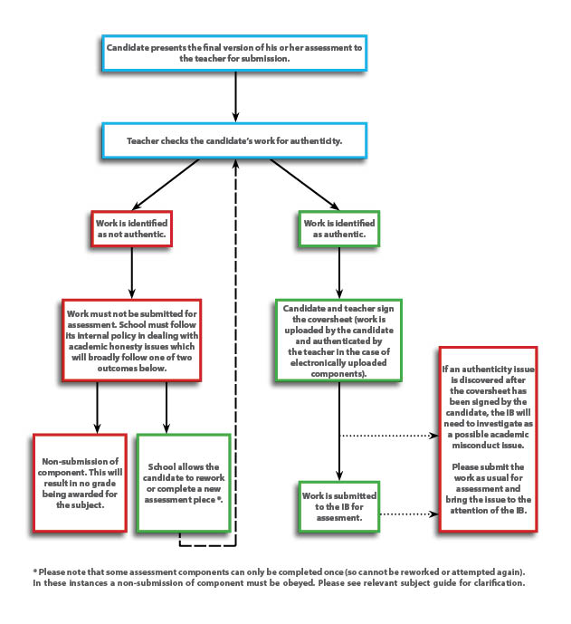

**Age-appropriate guidance**

Students are given guidance on how much more serious misconduct/malpractice is at the collegiate level. Here at MVHS, they are in a learning environment and are expected to grow through their experience across all subject areas. Students receive instruction on proper citation methods and referencing formats. Teachers provide instruction through the OWL Purdue online resource for formatting. The main school-wide format used is MLA. Some courses also instruct students on the use of APA style. Students are provided with access to bibliography resources both in print (samples of proper citations for different scenarios) and electronically. Turnitin is used as a tool to help students identify areas that are not properly cited.

**Scenarios and/or frequently asked questions**

According to *General Regulations Diploma Programme* (2015, p12-13),the IB Organization defines academic misconduct as behavior (whether deliberate or inadvertent) that results in, or may result in, the candidate or any other candidate gaining an unfair advantage in one or more components of assessment. Behavior that may disadvantage another candidate is also regarded as academic misconduct. Academic misconduct is a breach of these regulations and includes, but is not restricted to, the following:

a. plagiarism—this is defined as the representation, intentionally or unintentionally, of the ideas, words or work of another person without proper, clear and explicit acknowledgment. This includes paraphrasing sources, which also need to be cited properly.

b. collusion—this is defined as supporting academic misconduct by another candidate, for example, allowing one’s work to be copied or submitted for assessment by another

c. duplication of work—this is defined as the presentation of the same work for different assessment components and/or DP core requirements

d. misconduct during an IB examination (for example, taking unauthorized material into an examination, behavior that disrupts the examination or distracts other candidates, or communicating with another candidate)

e. any other behavior that gains an unfair advantage for a candidate or that affects the results of another candidate (for example, falsifying a CAS record, disclosure of information to and receipt of information from candidates about the content of an examination paper within 24 hours after a written examination via any form of communication/media).

**Procedures – reporting, recording, monitoring**

Teachers report incidents of academic misconduct to the assistant principals and/or the Dean of Students. The teacher completes a referral form describing the incident and provides a copy of the suspected malpractice. After investigation of the situation, if malpractice is confirmed, then the parents will be informed, the incident will be documented in the counseling screen on the student’s record, and the appropriate discipline will be assigned per MV Guide. The paperwork is sent to the Dean of Student’s secretary who documents the incident in the student’s discipline screen. Monitoring is done on an as needed basis depending on severity and frequency of the incidents.

If the student is suspected of malpractice on an IB assessment, then the teacher will inform the IB Coordinator, who will then submit the proper forms to IBO. If IBO requests additional documentation or statements, the IB Coordinator will then communicate with all parties to complete the necessary paperwork.

**The rights of the student, if suspected of a breach of academic honesty**

The student and parent are provided a copy of the *General Regulations Diploma Programme*. The school will inform the parents and students of suspected misconduct. If this occurs for an IB assessment, then the IB Coordinator will inform the student and parent of the alleged misconduct and the procedure for investigation. “The candidates and his or her legal guardians have the right to see evidence, statements, reports and correspondence about the case” (*Academic honesty*, p. 15). If the student chooses, he or she can submit a written defense and must be given time to do so.

**Consequences of academic misconduct**

The IBO has outlined the penalties imposed on a candidate found guilty of malpractice during an assessment. These are stated in section 12 of *Academic honesty.* The penalties that the IBO can impose are listed below:

* No score being awarded for the subject.
* Zero marks will be awarded for the assessment component concerned, but the candidate will still be eligible for a grade in the subject concerned.
* Or no penalty if there is no discernible evidence of malpractice.

**MVHS IB Honor Code**

Our IB Honor Code, specifying consequences to misconduct is more severe than the MVHS school-wide policy in order to prepare students for the severity of the collegiate response to malpractice. Malpractice includes the following: plagiarism, collusion, duplication of work, and any other behavior that gains an unfair advantage for a candidate. Offenses are accumulated over all subject areas for the two years of each program. The consequences are outlined below:

* 1st Offense: Credit loss for assignment, test, project; no make-up assignment permitted; discipline referral; entry into discipline file; parent-teacher-counselor-administrative conference; Saturday school is assigned. Final grade in class may be negatively affected.
* 2nd Offense: Credit loss for assignment, test, project; no make-up assignment permitted; discipline referral; entry into discipline file; parent-teacher-counselor-administrative conference; Saturday school is assigned. A behavior contract is created, notifying student and parent that one more offense will result in removal from the IB DP or IB MYP. Final grade in class may be negatively affected.
* 3rd Offense: Credit loss for assignment, test, project; no make-up assignment permitted; discipline referral; entry into discipline file; parent-teacher-counselor-administrative conference; Saturday school is assigned. Final grade in class may be negatively affected.

Student will be dismissed from the full Diploma Program or the MYP Certificate.

**A policy on review of the policy**

The policy will be reviewed annually by the leadership team and IB DP teachers in order to incorporate updates from IBO and feedback from current implementation of policy. This policy is connected to the assessment policy by reinforcing the integrity of assessment practices and ensuring supports and services are provided for inclusion students.